**Project 3 Report**

**CS 40800**

Group 13:

Connor Brown: [brow1325@purdue.edu](mailto:brow1325@purdue.edu)

Jakob Molskness: [jmolskn@purdue.edu](mailto:jmolskn@purdue.edu)

Nathan Adduci: [adducin@purdue.edu](mailto:adducin@purdue.edu)

**Part 1**

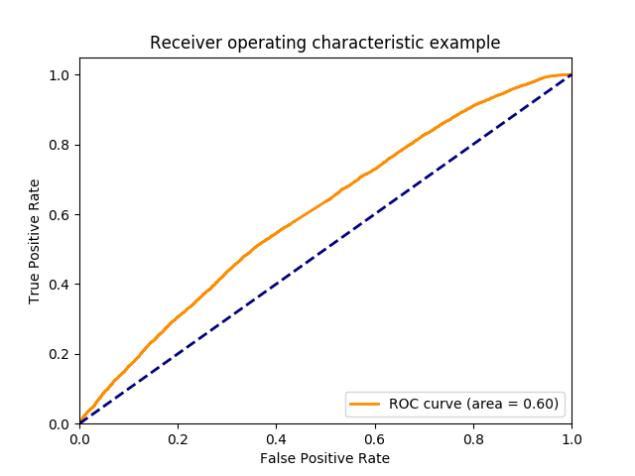

Buggy Rate Training: 21792 / 50000 43.584%

Buggy Rate Validation: 10850 / 25000 43.400%

Buggy Rate Testing: 11028 / 25000 44.112%

**Part 2**

Original Paper: <https://arxiv.org/pdf/1803.04831.pdf>

Implementing Repository: <https://github.com/titu1994/Keras-IndRNN>

(Note: The implementation was manually changed from keras to tensorflow.keras but is functionally identical)

This model is an independently recurrent neural network (IndRNN), which is a novel type of network developed to address existing problems in LSTM and GRU models. The cited paper found that for sequential data, the IndRNN is able to process more timesteps and layers than a traditional RNN in the same amount of compute time, yielding better performing results. Since code is by its nature sequential, we believed this would apply well to this project and decided to try it.

We did see a small improvement in accuracy, with an AUC of 0.61, up from the 0.60 we obtained in Part 1. While this is technically an improvement, it isn’t a significant one. However, it did take about an hour less to train our Part 2 model than the Part 1 model. This difference is significant not only because it uses less resources up front; it also indicates this model may scale better with additional training data than the original model did, allowing for better results in the same total compute time.

The ROC curve for our model is attached below. Our source code is also available in Appendix A of this document, and relies on two files: a modified form of the train_and_test.py from the skeleton, and a new file ind_rnn.py.

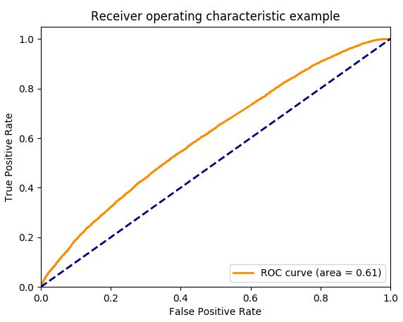

**Part 3**

Used the same learning algorithm as part 2, the two optimizations we implemented were removing comments and expanding the tokens accepted per line to 2000. I had to reduce the number of instances used to train my model to 50k from 100k, because my 100k run got killed after my ssh session disconnected (I think, at least) and the deadline was too soon to run it again with the tokens per line expansion. This same thing happening before the 2000 tokens per line version finished made it impossible for me to complete that part of this expansion, so I don’t have a graph for it. You can see several of these processes run over the last few days in my command history (adducin) if that helps to give us more points.

**Removing Comments**

Removing comments required code which can be seen in appendix B, it is highlighted in yellow in preprocessing.py. The only way I could figure out to do this was tracing the comment structure of a program and using python sub-array features to trim the array. Inline comments were still included because I didn’t want to parse individual lines of tokens. Below are the results I got:

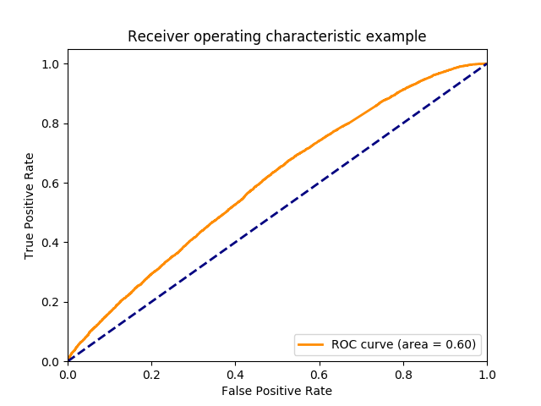

The ROC curve area decreased, which implies a slightly less accurate prediction model was created.It seems like the previous model may have had an artificially high true positive rate due to studying the comments at low false positive rates, which removing the comments changed. Further testing with the first method and this version’s preprocessing method would have to be done in order to properly prove this, to see if the curve changed proportionally.

**Removing Comments and Expanding Maximum Tokens per Line**

The version run with both comments removed and maximum tokens/line increased was unfortunately killed too early, leading to no useable data. From what was run, the buggy rate appears to be the same value, as shown below as output from the two ‘python calculate.py’ calls. The one with token length expansion is to the left, the previous call is to the right.

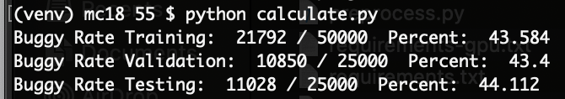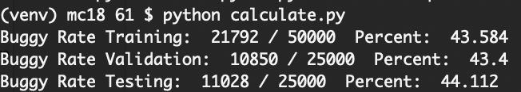

As these rates were identical, I’m going to assume there was no discernable difference. There are a few conclusions that could be taken from this finding, the first and most likely is that these results were actually from the same model, and was attained when I coppied the model from a previous run which had successfully run and I didn’t realize it, the second is that the samples gathered didn’t actually exceed 1000, and the last and least likely is that they were actually identical. I’m assuming the first, because the other two are unlikely from a statistical standpoint.

**Appendix A**

**train_and_test.py:**

import pickle

import pandas as pd

import numpy as np

import tensorflow_datasets as tfds

import tensorflow as tf

from tensorflow.keras.preprocessing.sequence import pad_sequences

from tensorflow.keras.callbacks import ModelCheckpoint

from tensorflow.keras.utils import Sequence

from sklearn.metrics import roc_curve, auc

import matplotlib.pyplot as plt

from ind_rnn import IndRNNCell, RNN

with open('data/y_train.pickle', 'rb') as handle:

Y_train = pickle.load(handle)

with open('data/y_test.pickle', 'rb') as handle:

Y_test = pickle.load(handle)

with open('data/y_valid.pickle', 'rb') as handle:

Y_valid = pickle.load(handle)

with open('data/x_train.pickle', 'rb') as handle:

X_train = pickle.load(handle)

with open('data/x_test.pickle', 'rb') as handle:

X_test = pickle.load(handle)

with open('data/x_valid.pickle', 'rb') as handle:

X_valid = pickle.load(handle)

with open('data/vocab_set.pickle', 'rb') as handle:

vocabulary_set = pickle.load(handle)

X_train = X_train[:100000] # Originally 50000

Y_train = Y_train[:100000] # Originally 50000

X_test = X_test[:25000] # Originally 25000

Y_test = Y_test[:25000] # Originally 25000

X_valid = X_valid[:25000] # Originally 25000

Y_valid = Y_valid[:25000] # Originally 25000

# Encode training, valid and test instances

encoder = tfds.features.text.TokenTextEncoder(vocabulary_set)

# Model Definition

cells = [IndRNNCell(128),

IndRNNCell(128)]

model = tf.keras.Sequential([

tf.keras.layers.Embedding(encoder.vocab_size, 64),

RNN(cells, input_shape=X_train.shape[1:]),

tf.keras.layers.Dense(64, activation='relu'),

tf.keras.layers.Dropout(0.5),

tf.keras.layers.Dense(1, activation='sigmoid')

])

model.compile(loss='binary_crossentropy',

optimizer=tf.keras.optimizers.Adam(1e-4),

metrics=['accuracy'])

model.summary()

batch_size = 16

# Building generators

class CustomGenerator(Sequence):

def __init__(self, text, labels, batch_size, num_steps=None):

self.text, self.labels = text, labels

self.batch_size = batch_size

self.len = np.ceil(len(self.text) / float(self.batch_size)).astype(np.int64)

if num_steps:

self.len = min(num_steps, self.len)

def __len__(self):

return self.len

def __getitem__(self, idx):

batch_x = self.text[idx * self.batch_size:(idx + 1) * self.batch_size]

batch_y = self.labels[idx * self.batch_size:(idx + 1) * self.batch_size]

return batch_x, batch_y

train_gen = CustomGenerator(X_train, Y_train, batch_size)

valid_gen = CustomGenerator(X_valid, Y_valid, batch_size)

test_gen = CustomGenerator(X_test, Y_test, batch_size)

# Training the model

checkpointer = ModelCheckpoint('data/models/model-{epoch:02d}-{val_loss:.5f}.hdf5', # Change to 02d

monitor='val_loss',

verbose=1,

save_best_only=True,

mode='min')

# callback_list = [checkpointer] #, , reduce_lr

# his1 = model.fit_generator(

# generator=train_gen,

# epochs=1,

# validation_data=valid_gen,

# callbacks=callback_list)

callback_list = [checkpointer] #, , reduce_lr

his1 = model.fit_generator(

generator=train_gen,

epochs=1,

validation_data=valid_gen)

predIdxs = model.predict_generator(test_gen, verbose=1)

fpr, tpr, _ = roc_curve(Y_test, predIdxs)

roc_auc = auc(fpr, tpr)

plt.figure()

lw = 2

plt.plot(fpr, tpr, color='darkorange', lw=lw, label='ROC curve (area = %0.2f)' % roc_auc)

plt.plot([0, 1], [0, 1], color='navy', lw=lw, linestyle='--')

plt.xlim([0.0, 1.0])

plt.ylim([0.0, 1.05])

plt.xlabel('False Positive Rate')

plt.ylabel('True Positive Rate')

plt.title('Receiver operating characteristic example')

plt.legend(loc="lower right")

plt.savefig('auc_model.png')

**train_and_test.py:**

from __future__ import absolute_import

import warnings

from tensorflow.keras import backend as K

from tensorflow.keras import activations

from tensorflow.keras import initializers

from tensorflow.keras import regularizers

from tensorflow.keras import constraints

from tensorflow.keras.layers import Layer

from tensorflow.keras.layers import InputSpec

#from tensorflow.keras.legacy import interfaces

from tensorflow.keras.layers import RNN

#from tensorflow.keras.layers.recurrent import _generate_dropout_mask

class IndRNNCell(Layer):

*""" NOTE: This package is sourced from the link below, but all dependencies have been reworked to use*

*tensorflow.keras rather than Keras (due to not having permission to install Keras on Cuda)*

*"""*

"""Independently Recurrent Neural Networks Cell class.

Derived from the paper [Independently Recurrent Neural Network (IndRNN): Building A Longer and Deeper RNN](https://arxiv.org/abs/1803.04831)

Ref: [Tensorflow implementation](https://github.com/batzner/indrnn)

# Arguments

units: Positive integer, dimensionality of the output space.

recurrent_clip_min: Can be one of None, -1 or float.

If None, clipping of weights will not take place.

If float, exact value will be used as clipping range

If -1, will calculate the clip value for `relu` activation

recurrent_clip_max: Can be one of None or float.

If None, clipping of weights will not take place.

If float, exact value will be used as clipping range

If -1, will calculate the clip value for `relu` activation

activation: Activation function to use

(see [activations](../activations.md)).

If you pass None, no activation is applied

(ie. "linear" activation: `a(x) = x`).

use_bias: Boolean, whether the layer uses a bias vector.

kernel_initializer: Initializer for the `kernel` weights matrix,

used for the linear transformation of the inputs

(see [initializers](../initializers.md)).

recurrent_initializer: Initializer for the `recurrent_kernel`

weights matrix, used for the linear transformation of the

recurrent state.

Can be `None` or an available initializer. Defaults to `None`.

If None, defaults to uniform initialization.

If None, and recurrent_clip_min/max is not None, then

it uses those clip values as for uniform initialization.

(see [initializers](../initializers.md)).

bias_initializer: Initializer for the bias vector

(see [initializers](../initializers.md)).

kernel_regularizer: Regularizer function applied to

the `kernel` weights matrix

(see [regularizer](../regularizers.md)).

recurrent_regularizer: Regularizer function applied to

the `recurrent_kernel` weights matrix

(see [regularizer](../regularizers.md)).

bias_regularizer: Regularizer function applied to the bias vector

(see [regularizer](../regularizers.md)).

kernel_constraint: Constraint function applied to

the `kernel` weights matrix

(see [constraints](../constraints.md)).

recurrent_constraint: Constraint function applied to

the `recurrent_kernel` weights matrix

(see [constraints](../constraints.md)).

bias_constraint: Constraint function applied to the bias vector

(see [constraints](../constraints.md)).

dropout: Float between 0 and 1.

Fraction of the units to drop for

the linear transformation of the inputs.

recurrent_dropout: Float between 0 and 1.

Fraction of the units to drop for

the linear transformation of the recurrent state.

implementation: Implementation mode, must be 2.

Mode 1 will structure its operations as a larger number of

smaller dot products and additions, whereas mode 2 will

batch them into fewer, larger operations. These modes will

have different performance profiles on different hardware and

for different applications.

"""

def __init__(self, units,

recurrent_clip_min=-1,

recurrent_clip_max=-1,

activation='relu',

use_bias=True,

kernel_initializer='glorot_uniform',

recurrent_initializer=None,

bias_initializer='zeros',

kernel_regularizer=None,

recurrent_regularizer=None,

bias_regularizer=None,

kernel_constraint=None,

recurrent_constraint=None,

bias_constraint=None,

dropout=0.,

recurrent_dropout=0.,

implementation=2,

**kwargs):

super(IndRNNCell, self).__init__(**kwargs)

if implementation != 2:

warnings.warn(

"IndRNN only supports implementation 2 for the moment. Defaulting to implementation = 2")

implementation = 2

if recurrent_clip_min is None or recurrent_clip_max is None:

recurrent_clip_min = None

recurrent_clip_max = None

self.units = units

self.recurrent_clip_min = recurrent_clip_min

self.recurrent_clip_max = recurrent_clip_max

self.activation = activations.get(activation)

self.use_bias = use_bias

self.kernel_initializer = initializers.get(kernel_initializer)

self.recurrent_initializer = initializers.get(recurrent_initializer) \

if recurrent_initializer is not None else None

self.bias_initializer = initializers.get(bias_initializer)

self.kernel_regularizer = regularizers.get(kernel_regularizer)

self.recurrent_regularizer = regularizers.get(recurrent_regularizer)

self.bias_regularizer = regularizers.get(bias_regularizer)

self.kernel_constraint = constraints.get(kernel_constraint)

self.recurrent_constraint = constraints.get(recurrent_constraint)

self.bias_constraint = constraints.get(bias_constraint)

self.dropout = min(1., max(0., dropout))

self.recurrent_dropout = min(1., max(0., recurrent_dropout))

self.implementation = implementation

self.state_size = (self.units,)

self._dropout_mask = None

self._recurrent_masks = None

def build(self, input_shape):

input_dim = input_shape[-1]

if self.recurrent_clip_min == -1 or self.recurrent_clip_max == -1:

self.recurrent_clip_min = 0.0

if hasattr(self, 'timesteps') and self.timesteps is not None:

self.recurrent_clip_max = pow(2.0, 1. / self.timesteps)

else:

warnings.warn("IndRNNCell: Number of timesteps could not be determined. \n"

"Defaulting to max clipping range of 1.0. \n"

"If this model was trained using a specific timestep during training, "

"inference may be wrong due to this default setting.\n"

"Please ensure that you use the same number of timesteps during training "

"and evaluation")

self.recurrent_clip_max = 1.0

self.kernel = self.add_weight(shape=(input_dim, self.units),

name='input_kernel',

initializer=self.kernel_initializer,

regularizer=self.kernel_regularizer,

constraint=self.kernel_constraint)

if self.recurrent_initializer is None:

if self.recurrent_clip_min is not None and self.recurrent_clip_max is not None:

initialization_value = min(self.recurrent_clip_max, 1.0)

self.recurrent_initializer = initializers.RandomUniform(-initialization_value,

initialization_value)

else:

self.recurrent_initializer = initializers.RandomUniform(-1.0, 1.0)

self.recurrent_kernel = self.add_weight(shape=(self.units,),

name='recurrent_kernel',

initializer=self.recurrent_initializer,

regularizer=self.recurrent_regularizer,

constraint=self.recurrent_constraint)

if self.recurrent_clip_min is not None and self.recurrent_clip_max is not None:

if abs(self.recurrent_clip_min):

abs_recurrent_kernel = K.abs(self.recurrent_kernel)

min_recurrent_kernel = K.maximum(abs_recurrent_kernel, abs(self.recurrent_clip_min))

self.recurrent_kernel = K.sign(self.recurrent_kernel) * min_recurrent_kernel

self.recurrent_kernel = K.clip(self.recurrent_kernel,

self.recurrent_clip_min,

self.recurrent_clip_max)

if self.use_bias:

bias_initializer = self.bias_initializer

self.bias = self.add_weight(shape=(self.units,),

name='bias',

initializer=bias_initializer,

regularizer=self.bias_regularizer,

constraint=self.bias_constraint)

else:

self.bias = None

self.built = True

def _generate_dropout_mask(ones, rate, training=None, count=1):

def dropped_inputs():

return K.dropout(ones, rate)

if count > 1:

return [

K.in_train_phase(dropped_inputs, ones, training=training)

for _ in range(count)

]

return K.in_train_phase(dropped_inputs, ones, training=training)

def call(self, inputs, states, training=None):

if 0 < self.dropout < 1 and self._dropout_mask is None:

self._dropout_mask = _generate_dropout_mask(

K.ones_like(inputs),

self.dropout,

training=training,

count=1)

if (0 < self.recurrent_dropout < 1 and

self._recurrent_masks is None):

_recurrent_mask = _generate_dropout_mask(

K.ones_like(states[0]),

self.recurrent_dropout,

training=training,

count=1)

self._recurrent_masks = _recurrent_mask

# dropout matrices for input units

dp_mask = self._dropout_mask

# dropout matrices for recurrent units

rec_dp_masks = self._recurrent_masks

h_tm1 = states[0] # previous state

if 0. < self.dropout < 1.:

inputs *= dp_mask[0]

if 0. < self.recurrent_dropout < 1.:

h_tm1 *= rec_dp_masks[0]

h = K.dot(inputs, self.kernel)

h = h + (h_tm1 * self.recurrent_kernel)

if self.use_bias:

h = K.bias_add(h, self.bias)

h = self.activation(h)

if 0 < self.dropout + self.recurrent_dropout:

if training is None:

h._uses_learning_phase = True

return h, [h]

def get_config(self):

config = {'units': self.units,

'recurrent_clip_min': self.recurrent_clip_min,

'recurrent_clip_max': self.recurrent_clip_max,

'activation': activations.serialize(self.activation),

'use_bias': self.use_bias,

'kernel_initializer': initializers.serialize(self.kernel_initializer),

'recurrent_initializer': initializers.serialize(self.recurrent_initializer),

'bias_initializer': initializers.serialize(self.bias_initializer),

'kernel_regularizer': regularizers.serialize(self.kernel_regularizer),

'recurrent_regularizer': regularizers.serialize(self.recurrent_regularizer),

'bias_regularizer': regularizers.serialize(self.bias_regularizer),

'kernel_constraint': constraints.serialize(self.kernel_constraint),

'recurrent_constraint': constraints.serialize(self.recurrent_constraint),

'bias_constraint': constraints.serialize(self.bias_constraint),

'dropout': self.dropout,

'recurrent_dropout': self.recurrent_dropout,

'implementation': self.implementation}

base_config = super(IndRNNCell, self).get_config()

return dict(list(base_config.items()) + list(config.items()))

class IndRNN(RNN):

*"""Independently Recurrent Neural Networks Cell class.*

*Derived from the paper [Independently Recurrent Neural Network (IndRNN): Building A Longer and Deeper RNN](https://arxiv.org/abs/1803.04831)*

*Ref: [Tensorflow implementation](https://github.com/batzner/indrnn)*

*# Arguments*

*units: Positive integer, dimensionality of the output space.*

*recurrent_clip_min: Can be one of None, -1 or float.*

*If None, clipping of weights will not take place.*

*If float, exact value will be used as clipping range*

*If -1, computes the default clipping range for Relu activations*

*recurrent_clip_max: Can be one of None, -1 or float.*

*If None, clipping of weights will not take place.*

*If float, exact value will be used as clipping range*

*If -1, computes the default clipping range for Relu activations*

*activation: Activation function to use*

*(see [activations](../activations.md)).*

*If you pass None, no activation is applied*

*(ie. "linear" activation: `a(x) = x`).*

*use_bias: Boolean, whether the layer uses a bias vector.*

*kernel_initializer: Initializer for the `kernel` weights matrix,*

*used for the linear transformation of the inputs.*

*(see [initializers](../initializers.md)).*

*recurrent_initializer: Initializer for the `recurrent_kernel`*

*weights matrix,*

*used for the linear transformation of the recurrent state.*

*(see [initializers](../initializers.md)).*

*bias_initializer: Initializer for the bias vector*

*(see [initializers](../initializers.md)).*

*unit_forget_bias: Boolean.*

*If True, add 1 to the bias of the forget gate at initialization.*

*Setting it to true will also force `bias_initializer="zeros"`.*

*This is recommended in [Jozefowicz et al.](http://www.jmlr.org/proceedings/papers/v37/jozefowicz15.pdf)*

*kernel_regularizer: Regularizer function applied to*

*the `kernel` weights matrix*

*(see [regularizer](../regularizers.md)).*

*recurrent_regularizer: Regularizer function applied to*

*the `recurrent_kernel` weights matrix*

*(see [regularizer](../regularizers.md)).*

*bias_regularizer: Regularizer function applied to the bias vector*

*(see [regularizer](../regularizers.md)).*

*activity_regularizer: Regularizer function applied to*

*the output of the layer (its "activation").*

*(see [regularizer](../regularizers.md)).*

*kernel_constraint: Constraint function applied to*

*the `kernel` weights matrix*

*(see [constraints](../constraints.md)).*

*recurrent_constraint: Constraint function applied to*

*the `recurrent_kernel` weights matrix*

*(see [constraints](../constraints.md)).*

*bias_constraint: Constraint function applied to the bias vector*

*(see [constraints](../constraints.md)).*

*dropout: Float between 0 and 1.*

*Fraction of the units to drop for*

*the linear transformation of the inputs.*

*recurrent_dropout: Float between 0 and 1.*

*Fraction of the units to drop for*

*the linear transformation of the recurrent state.*

*implementation: Implementation mode, either 1 or 2.*

*Mode 1 will structure its operations as a larger number of*

*smaller dot products and additions, whereas mode 2 will*

*batch them into fewer, larger operations. These modes will*

*have different performance profiles on different hardware and*

*for different applications.*

*return_sequences: Boolean. Whether to return the last output.*

*in the output sequence, or the full sequence.*

*return_state: Boolean. Whether to return the last state*

*in addition to the output.*

*go_backwards: Boolean (default False).*

*If True, process the input sequence backwards and return the*

*reversed sequence.*

*stateful: Boolean (default False). If True, the last state*

*for each sample at index i in a batch will be used as initial*

*state for the sample of index i in the following batch.*

*unroll: Boolean (default False).*

*If True, the network will be unrolled,*

*else a symbolic loop will be used.*

*Unrolling can speed-up a RNN,*

*although it tends to be more memory-intensive.*

*Unrolling is only suitable for short sequences.*

*# References*

*- [Learning to forget: Continual prediction with NestedLSTM](http://www.mitpressjournals.org/doi/pdf/10.1162/089976600300015015)*

*- [Supervised sequence labeling with recurrent neural networks](http://www.cs.toronto.edu/~graves/preprint.pdf)*

*- [A Theoretically Grounded Application of Dropout in Recurrent Neural Networks](http://arxiv.org/abs/1512.05287)*

*- [Independently Recurrent Neural Network (IndRNN): Building A Longer and Deeper RNN](https://arxiv.org/abs/1803.04831)*

*"""*

#@interfaces.legacy_recurrent_support

def __init__(self, units,

recurrent_clip_min=-1,

recurrent_clip_max=-1,

activation='relu',

use_bias=True,

kernel_initializer='glorot_uniform',

recurrent_initializer=None,

bias_initializer='zeros',

kernel_regularizer=None,

recurrent_regularizer=None,

bias_regularizer=None,

activity_regularizer=None,

kernel_constraint=None,

recurrent_constraint=None,

bias_constraint=None,

dropout=0.,

recurrent_dropout=0.,

implementation=2,

return_sequences=False,

return_state=False,

go_backwards=False,

stateful=False,

unroll=False,

**kwargs):

if implementation == 0:

warnings.warn('`implementation=0` has been deprecated, '

'and now defaults to `implementation=2`.'

'Please update your layer call.')

if K.backend() == 'theano':

warnings.warn(

'RNN dropout is no longer supported with the Theano backend '

'due to technical limitations. '

'You can either set `dropout` and `recurrent_dropout` to 0, '

'or use the TensorFlow backend.')

dropout = 0.

recurrent_dropout = 0.

cell = IndRNNCell(units, 2,

recurrent_clip_min=recurrent_clip_min,

recurrent_clip_max=recurrent_clip_max,

activation=activation,

use_bias=use_bias,

kernel_initializer=kernel_initializer,

recurrent_initializer=recurrent_initializer,

bias_initializer=bias_initializer,

kernel_regularizer=kernel_regularizer,

recurrent_regularizer=recurrent_regularizer,

bias_regularizer=bias_regularizer,

kernel_constraint=kernel_constraint,

recurrent_constraint=recurrent_constraint,

bias_constraint=bias_constraint,

dropout=dropout,

recurrent_dropout=recurrent_dropout,

implementation=implementation)

super(IndRNN, self).__init__(cell,

return_sequences=return_sequences,

return_state=return_state,

go_backwards=go_backwards,

stateful=stateful,

unroll=unroll,

**kwargs)

self.activity_regularizer = regularizers.get(activity_regularizer)

def build(self, input_shape):

timesteps = input_shape[1]

if timesteps is None:

warnings.warn("Number of timesteps was not provided. If this model is being used for training purposes, \n"

"it is recommended to provide a finite number of timesteps when defining the input shape, \n"

"so as to initialize the weights of the recurrent kernel properly and avoid exploding gradients.")

self.cell.timesteps = timesteps

super(IndRNN, self).build(input_shape)

def call(self, inputs, mask=None, training=None, initial_state=None, constants=None):

self.cell._dropout_mask = None

self.cell._recurrent_masks = None

return super(IndRNN, self).call(inputs,

mask=mask,

training=training,

initial_state=initial_state,

constants=constants)

@property

def units(self):

return self.cell.units

@property

def recurrent_clip_min(self):

return self.cell.recurrent_clip_min

@property

def recurrent_clip_max(self):

return self.cell.recurrent_clip_max

@property

def activation(self):

return self.cell.activation

@property

def use_bias(self):

return self.cell.use_bias

@property

def kernel_initializer(self):

return self.cell.kernel_initializer

@property

def recurrent_initializer(self):

return self.cell.recurrent_initializer

@property

def bias_initializer(self):

return self.cell.bias_initializer

@property

def kernel_regularizer(self):

return self.cell.kernel_regularizer

@property

def recurrent_regularizer(self):

return self.cell.recurrent_regularizer

@property

def bias_regularizer(self):

return self.cell.bias_regularizer

@property

def kernel_constraint(self):

return self.cell.kernel_constraint

@property

def recurrent_constraint(self):

return self.cell.recurrent_constraint

@property

def bias_constraint(self):

return self.cell.bias_constraint

@property

def dropout(self):

return self.cell.dropout

@property

def recurrent_dropout(self):

return self.cell.recurrent_dropout

@property

def implementation(self):

return self.cell.implementation

def get_config(self):

config = {'units': self.units,

'recurrent_clip_min': self.recurrent_clip_min,

'recurrent_clip_max': self.recurrent_clip_max,

'activation': activations.serialize(self.activation),

'use_bias': self.use_bias,

'kernel_initializer': initializers.serialize(self.kernel_initializer),

'recurrent_initializer': initializers.serialize(self.recurrent_initializer),

'bias_initializer': initializers.serialize(self.bias_initializer),

'kernel_regularizer': regularizers.serialize(self.kernel_regularizer),

'recurrent_regularizer': regularizers.serialize(self.recurrent_regularizer),

'bias_regularizer': regularizers.serialize(self.bias_regularizer),

'activity_regularizer': regularizers.serialize(self.activity_regularizer),

'kernel_constraint': constraints.serialize(self.kernel_constraint),

'recurrent_constraint': constraints.serialize(self.recurrent_constraint),

'bias_constraint': constraints.serialize(self.bias_constraint),

'dropout': self.dropout,

'recurrent_dropout': self.recurrent_dropout,

'implementation': self.implementation}

base_config = super(IndRNN, self).get_config()

del base_config['cell']

return dict(list(base_config.items()) + list(config.items()))

@classmethod

def from_config(cls, config):

if 'implementation' in config and config['implementation'] == 0:

config['implementation'] = 2

return cls(**config)

**Appendix B**

**preprocess.py**

import pickle

import pandas as pd

import numpy as np

import tensorflow_datasets as tfds

import tensorflow as tf

from tensorflow.keras.preprocessing.sequence import pad_sequences

maxlen = 1000

print("bbbb")

# Loading tokenized data

with open('data/tokenized_train.pickle', 'rb') as handle:

train = pickle.load(handle)

with open('data/tokenized_valid.pickle', 'rb') as handle:

valid = pickle.load(handle)

with open('data/tokenized_test.pickle', 'rb') as handle:

test = pickle.load(handle)

# Reshape instances:

def reshape_instances(df):

df["input"] = df["context_before"].apply(lambda x: " ".join(x)) + " <START> " + df["instance"].apply(lambda x: " ".join(x)) + " <END> " + df["context_after"].apply(lambda x: " ".join(x))

X_df = []

Y_df = []

i = 0

print("asdf")

block = False

for index, rows in df.iterrows():

flag = 0

start = 0

end = 0

endalt = 0

comm = False

blockStart = False

for token in rows.input:

endalt+=1

#if not block:

# end+=1

if(block):

if(not blockStart):

start +=1

if(flag == 1 and '/' in token):

block = False

comm = not blockStart #This was an inline comment block, too hot to handle (ignore it)

blockStart = False

end = endalt # reset the end value, we need the end of this line.

if('*' in token):

flag=1

else:

flag = 0

else:

end+=1

if(flag == 1 and '*' in token):

flag=1

end-=2

comm = True

block = True

blockStart = True

elif('/' in token):

if flag == 0:

flag=1

elif flag == 1:

comm = True

end -= 2

break

else:

flag=0

if not block or not comm:

X_df.append(rows.input)

Y_df.append(rows.is_buggy)

else:

X_df.append(rows.input[start:end])

Y_df.append(rows.is_buggy)

return X_df, Y_df

print("aaa")

#reshape_instances(train)

#reshape_instances(test)

#reshape_instances(valid)

#"""

X_train, Y_train = reshape_instances(train)

X_test, Y_test = reshape_instances(test)

X_valid, Y_valid = reshape_instances(valid)

# Use a subset of data to save time

# You can change it in Part(III) to improve your result

#Removed 2 zeroes.

X_train = X_train[:50000]

Y_train = Y_train[:50000]

X_test = X_test[:25000]

Y_test = Y_test[:25000]

X_valid = X_valid[:25000]

Y_valid = Y_valid[:25000]

# Build vocabulary and encoder from the training instances

vocabulary_set = set()

#i = 0

for data in X_train:

#if(i % 5000 == 0):

#print(i + ": [" + data + "]\n")

vocabulary_set.update(data.split())

# Encode training, valid and test instances

encoder = tfds.features.text.TokenTextEncoder(vocabulary_set)

def encode(text):

encoded_text = encoder.encode(text)

return encoded_text

X_train = list(map(lambda x: encode(x), X_train))

X_test = list(map(lambda x: encode(x), X_test))

X_valid = list(map(lambda x: encode(x), X_valid))

X_train = pad_sequences(X_train, maxlen=maxlen)

X_test = pad_sequences(X_test, maxlen=maxlen)

X_valid = pad_sequences(X_valid, maxlen=maxlen)

with open('data/y_train.pickle', 'wb') as handle:

pickle.dump(Y_train, handle)

with open('data/y_test.pickle', 'wb') as handle:

pickle.dump(Y_test, handle)

with open('data/y_valid.pickle', 'wb') as handle:

pickle.dump(Y_valid, handle)

with open('data/x_train.pickle', 'wb') as handle:

pickle.dump(X_train, handle)

with open('data/x_test.pickle', 'wb') as handle:

pickle.dump(X_test, handle)

with open('data/x_valid.pickle', 'wb') as handle:

pickle.dump(X_valid, handle)

with open('data/vocab_set.pickle', 'wb') as handle:

pickle.dump(vocabulary_set, handle)

#"""